**BIG IDEAS FROM CLASS SEVEN:**

**PASSOVER: THE JEWISH MASTER STORY**

**Through its detailed rituals and symbols, Passover helps Jews to re-experience our central story—liberation from Egyptian slavery—and to carry its message about the imperative of working for human dignity and liberation into our contemporary consciousness.**

**THE PASSOVER DIET PLAN:** On Passover, we strictly refrain from eating any HAMETZ (leavened products) and we take great pains to completely remove every single crumb of them from our homes. Ashkenazim are traditionally even more strict, also avoiding products that resemble hametz called KITNIYOT (rice, beans, corn, etc).

**THE PASSOVER MEAL:** On the first two nights of Passover, we hold a ritual meal called a SEDER, during which we tell the tale of our liberation from Egypt through symbolic foods, songs, stories, discussion, and questions. The most important symbolic foods, aside from the all- important MATZAH, are shown below:

PASSOVER FOODS

Shankbone: Represents the Passover offering from the days of the Temple.

Karpas & Eggs: Represent the Spring season and the theme of national and personal rebirth.

Maror: Bitter herbs represent the harshness of our enslavement and degradation.

Charoset: Sweet mixture of fruits and nuts represent both the bricks we made in our enslavement and the sweet taste of freedom.

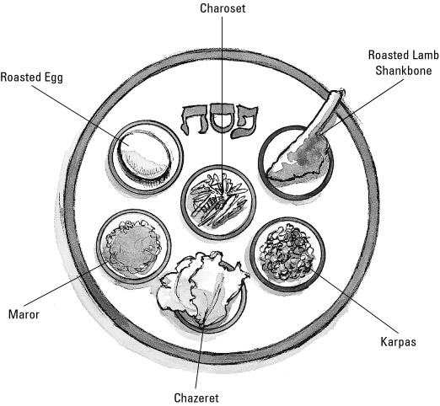

The most important aspect of the Passover holiday is that we are obligated to not just re-tell the story of our liberation from Egypt, but we are required to identify personally with that story— as it says in the Haggadah:

**IN EVERY GENERATION A PERSON IS OBLIGATED TO SEE THEMSELVES AS THOUGH THEY PERSONALLY CAME OUT EGYPT.**

And because we personally know and understand the suffering of those who are not free, we have a sacred obligation to work for the liberation and dignity of all who live under any form of oppression.