Miller Introduction to Judaism Program
American Jewish University
CLASS #1:
From Creation to the
Edge of the Wilderness
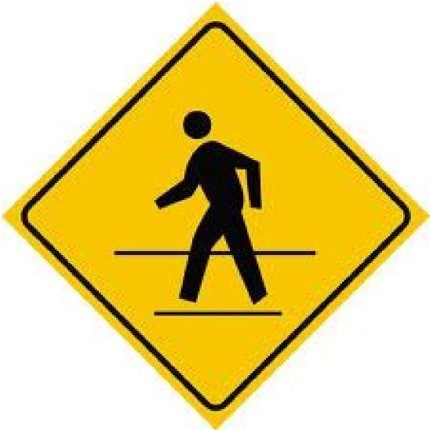
“All beginnings are difficult.”
-Rashi on Exodus 19:5
TORAH— A Drama in Six Acts
Pre-History Genesis 1 - 11
Patriarchs & Matriarchs Genesis 12 - 50
Slavery to Redemption Exodus 1 - 18
Covenant at Sinai Exodus 19 - Numbers 9
Wilderness Numbers 10 - 36
Moses’ Final Speech Deuteronomy
Miller Introduction to Judaism Program at American Jewish University
4
AN EVOLVING HISTORY OF COVENANT
How are each of these a story of covenant? What responsibilities does God take on toward human beings? What responsibilities do human beings take on toward God? What makes these signature moments in the life of the Jewish People?
B’Tzelem Elohim: In the Image of God
Genesis 1:26-31
And God said, "Let us make man in our image, after our likeness. They shall rule the fish of the sea, the birds of the sky, the cattle, the whole earth, and all the creeping things that creep on earth." And God created man in His image, in the image of God He created him; male and female He created them. God blessed them and God said to them, "Be fertile and increase, fill the earth and master it; and rule the fish of the sea, the birds of the sky, and all the living things that creep on earth...”And God saw all that He had made, and found it very good. And there was evening and there was morning, the sixth day.
Covenant with Noah
Genesis 9:8-17
God said to Noah and to his sons with him, "I now establish My covenant with you and your offspring to come, and with every living thing that is with you — birds, cattle, and every wild beast as well — all that have come out of the ark, every living thing on earth. I will maintain My covenant with you: never again shall all flesh be cut off by the waters of a flood, and never again shall there be a flood to destroy the earth."
God further said, "This is the sign that I set for the covenant between Me and you, and every living creature with you, for all ages to come. I have set My bow in the clouds, and it shall serve as a sign of the covenant between Me and the earth. When I bring clouds over the earth, and the bow appears in the clouds, I will remember My covenant between Me and you and every living creature among all flesh, so that the waters shall
never again become a flood to destroy all flesh.
5
Miller Introduction to Judaism Program at American Jewish University
Lech Lecha: Covenant with Abraham
Genesis 12:1-5
God said to Abram, Go forth from your native land, from your birthplace, and from your father's house to the land that I will show you.
I will make of you a great nation,
And I will bless you;
I will make your name great, And you shall be a blessing. I will bless those who bless you And curse him that curses you; And all the families of the earth Shall bless themselves by you."
Abram went forth as the Lord had commanded him, and Lot went with him. Abram was seventy-five years old when he left Haran. Abram took his wife Sarai and his brother's son Lot, and all the wealth that they had amassed, and the souls that they had made in Haran; and they set out for the land of Canaan.
Revelation at Sinai: Covenant with the Jewish People
Exodus 19:1-8
On the third new moon after the Israelites had gone forth from the land of Egypt, on that very day, they entered the wilderness of Sinai. Moses went up to God: Adonai called to him from the mountain, saying, "Thus shall you say to the house of Jacob and declare to the children of Israel: 'You have seen what I did to the Egyptians, how I carried you on eagles' wings and brought you to Me. Now then, if you will obey Me faithfully and keep My covenant, you shall be My treasured possession among all the peoples. Indeed, all the earth is Mine, but you shall be to Me a kingdom of priests and a holy nation.' These are the words that you shall speak to the children of Israel.’ Moses came and summoned the elders of the people and put before them all that the God had commanded him. All the people answered as one, saying, "All that Adonai has spoken we will do!" And Moses brought back the people's words to God.
6
Miller Introduction to Judaism Program at American Jewish University
Sh’ma Yisrael: Love Adonai Your God
Deuteronomy 6:1-9
And this is the Instruction — the laws and the rules — that the Lord your God has commanded me to impart to you, to be observed in the land that you are about to cross into and occupy, so that you, your children, and your children's children may revere the Lord your God and follow, as long as you live, all God’s laws and commandments, so that you may long endure. Follow willingly and faithfully, that it may go well with you and that you may increase greatly in a land flowing with milk and honey, as Adonai, the God of your ancestors, spoke to you.
Hear, O Israel! Adonai is our God, Adonai is One. You shall love Adonai your God with all your heart and with all your soul and with all your might. Take to heart these instructions with which I charge you this day. Teach them upon your children. Recite them when you stay at home and when you are away, when you lie down and when you get up. Bind them as a sign on your hand and let them be a reminder between your eyes; write them on your doorposts and your gates.
Choose Life: At the Edge of the Promised Land
Deuteronomy 30:11-20
Surely, this Torah which I enjoin upon you this day is not too baffling for you, nor is it beyond reach. It is not in the heavens, that you should say, "Who among us can go up to the heavens and get it for us and impart it to us, that we may observe it?" Neither is it beyond the sea, that you should say, "Who among us can cross the the sea and get it for us and impart it to us, that we may observe it?" No, the thing is very close to you, in your mouth and in your heart
I call heaven and earth to witness this day: I have put before you life and death, blessing and curse. Choose life! — so that you and your offspring would live — by loving Adonai your God, heeding God’s commands, and holding fast to God. For thereby you shall have life and shall long endure upon the soil that the Lord swore to your ancestors, Abraham, Isaac, and Jacob, to give to them.
⁷
Miller Introduction to Judaism Program at American Jewish University
A human being is called a “walker,” always having to go from one rung to another. For makes things seem natural, and this sense of “nature” hides the inner light. This is true even of Torah and the mitzvot; when we do them out of habit, they become our nature, and we forget their inward meaning.
This is why the Torah says, “leave your land”—a person must always keep walking, “to a land that I will show you” always to some new fulfillment. This is why a person is called a “walker.” Whoever stands still is not renewed, for nature holds him fast.
-Sefat Emet, Hasidic commentary on the Torah c. 1890
Take a few moments to reflect on what this beginning means to you:

8

Miller Introduction to Judaism Program at American Jewish University

